**Sets in Python**

* Difficulty Level : [Easy](https://www.geeksforgeeks.org/easy/)
* Last Updated : 15 Jul, 2022

A Set is an unordered collection data type that is iterable, mutable and has no duplicate elements.

*Set is define in { }*

The major advantage of using a set, as opposed to a list, is that it has a highly optimized method for checking whether a specific element is contained in the set. This is based on a data structure known as a [hash table](https://www.geeksforgeeks.org/hashing-set-1-introduction/). Since sets are unordered, we cannot access items using indexes like we do in [lists](https://www.geeksforgeeks.org/python-list/).

**Examples of Sets**

* Python3

|  |
| --- |
| var = {"Geeks", "for", "Geeks"}  type(var) |

**Output:**

set

[set()](https://www.geeksforgeeks.org/python-set-method/) methods is used to types conversion in Python.

* Python3

|  |
| --- |
| # Python program to  # demonstrate sets    # Same as {"a", "b", "c"}  myset = set(["a", "b", "c"])  print(myset)    # Adding element to the set  myset.add("d")  print(myset) |

**Output:**

{'c', 'b', 'a'}

{'d', 'c', 'b', 'a'}

**Python Frozen Sets**

**Frozen sets** in Python are immutable objects that only support methods and operators that produce a result without affecting the frozen set or sets to which they are applied. It can be done with [frozenset() method in Python.](https://www.geeksforgeeks.org/frozenset-in-python/)

While elements of a set can be modified at any time, elements of the frozen set remain the same after creation.

If no parameters are passed, it returns an empty frozenset.

* Python

|  |
| --- |
| # Python program to demonstrate differences  # between normal and frozen set    # Same as {"a", "b","c"}  normal_set = set(["a", "b","c"])    print("Normal Set")  print(normal_set)    # A frozen set  frozen_set = frozenset(["e", "f", "g"])    print("\nFrozen Set")  print(frozen_set)    # Uncommenting below line would cause error as  # we are trying to add element to a frozen set  # frozen_set.add("h") |

**Output:**

Normal Set

set(['a', 'c', 'b'])

Frozen Set

frozenset(['e', 'g', 'f'])

**Internal working of Set**

This is based on a data structure known as a [hash table](https://www.geeksforgeeks.org/hashing-set-1-introduction/).   
If Multiple values are present at the same index position, then the value is appended to that index position, to form a Linked List. In, Python Sets are implemented using dictionary with dummy variables, where key beings the members set with greater optimizations to the time complexity.

**Set Implementation:**

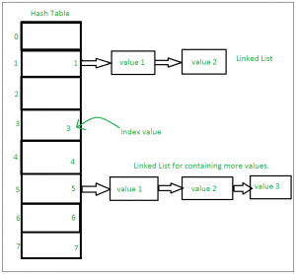

Sets with Numerous operations on a single HashTable:

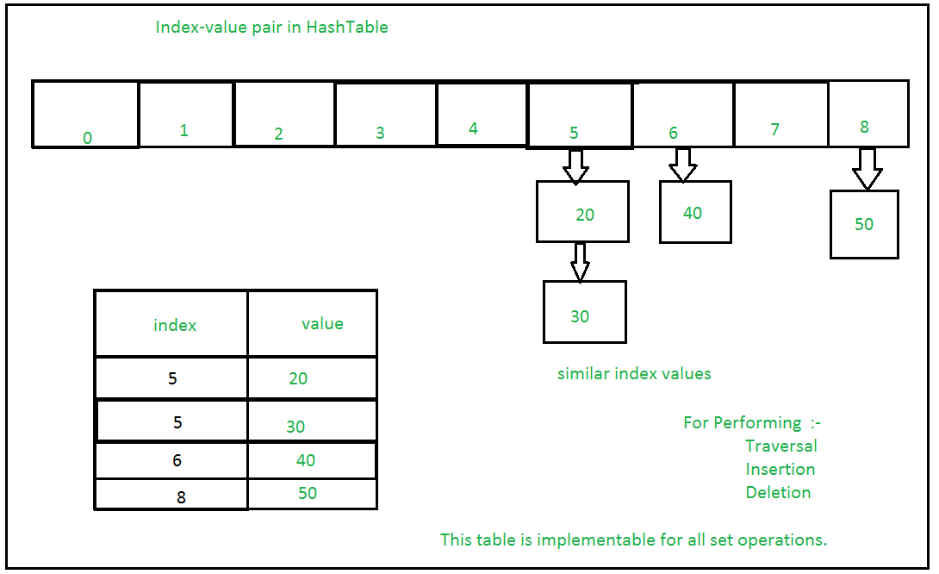

**Methods for Sets**

**Adding elements**

Insertion in set is done through set.add() function, where an appropriate record value is created to store in the hash table. Same as checking for an item, i.e., O(1) on average. However, in worst case it can become O(n).

* Python3

|  |
| --- |
| # A Python program to  # demonstrate adding elements  # in a set    # Creating a Set  people = {"Jay", "Idrish", "Archi"}    print("People:", end = " ")  print(people)    # This will add Daxit  # in the set  people.add("Daxit")    # Adding elements to the  # set using iterator  for i in range(1, 6):      people.add(i)    print("\nSet after adding element:", end = " ")  print(people) |

**Output:**

People: {'Idrish', 'Archi', 'Jay'}

Set after adding element: {1, 2, 3, 4, 5, 'Idrish', 'Archi', 'Jay', 'Daxit'}

**Union**

Two sets can be merged using union() function or | operator. Both Hash Table values are accessed and traversed with merge operation perform on them to combine the elements, at the same time duplicates are removed. Time Complexity of this is O(len(s1) + len(s2)) where s1 and s2 are two sets whose union needs to be done.

* Python3

|  |
| --- |
| # Python Program to  # demonstrate union of  # two sets    people = {"Jay", "Idrish", "Archil"}  vampires = {"Karan", "Arjun"}  dracula = {"Deepanshu", "Raju"}    # Union using union()  # function  population = people.union(vampires)    print("Union using union() function")  print(population)    # Union using "|"  # operator  population = people|dracula    print("\nUnion using '|' operator")  print(population) |

**Output:**

Union using union() function

{'Karan', 'Idrish', 'Jay', 'Arjun', 'Archil'}

Union using '|' operator

{'Deepanshu', 'Idrish', 'Jay', 'Raju', 'Archil'}

**Intersection**

This can be done through intersection() or & operator. Common Elements are selected. They are similar to iteration over the Hash lists and combining the same values on both the Table. Time Complexity of this is O(min(len(s1), len(s2)) where s1 and s2 are two sets whose union needs to be done.

* Python3

|  |
| --- |
| # Python program to  # demonstrate intersection  # of two sets    set1 = set()  set2 = set()    for i in range(5):      set1.add(i)    for i in range(3,9):      set2.add(i)    # Intersection using  # intersection() function  set3 = set1.intersection(set2)    print("Intersection using intersection() function")  print(set3)    # Intersection using  # "&" operator  set3 = set1 & set2    print("\nIntersection using '&' operator")  print(set3) |

**Output:**

Intersection using intersection() function

{3, 4}

Intersection using '&' operator

{3, 4}

**Difference**

To find difference in between sets. Similar to find difference in linked list. This is done through difference() or – operator. Time complexity of finding difference s1 – s2 is O(len(s1))

* Python3

|  |
| --- |
| # Python program to  # demonstrate difference  # of two sets    set1 = set()  set2 = set()    for i in range(5):      set1.add(i)    for i in range(3,9):      set2.add(i)    # Difference of two sets  # using difference() function  set3 = set1.difference(set2)    print(" Difference of two sets using difference() function")  print(set3)    # Difference of two sets  # using '-' operator  set3 = set1 - set2    print("\nDifference of two sets using '-' operator")  print(set3) |

**Output:**

Difference of two sets using difference() function

{0, 1, 2}

Difference of two sets using '-' operator

{0, 1, 2}

**Clearing sets**

Clear() method empties the whole set.

* Python3

|  |
| --- |
| # Python program to  # demonstrate clearing  # of set    set1 = {1,2,3,4,5,6}    print("Initial set")  print(set1)    # This method will remove  # all the elements of the set  set1.clear()    print("\nSet after using clear() function")  print(set1) |

**Output:**

Initial set

{1, 2, 3, 4, 5, 6}

Set after using clear() function

set()

**However, there are two major pitfalls in Python sets:**

1. The set doesn’t maintain elements in any particular order.
2. Only instances of immutable types can be added to a Python set.

**Time complexity of Sets**

| Operation | Average case | Worst Case | notes |
| --- | --- | --- | --- |
| x in s | O(1) | O(n) |  |
| Union s|t | O(len(s)+len(t)) |  |  |
| Intersection s&t | O(min(len(s), len(t)) | O(len(s) * len(t)) | replace “min” with “max” if t is not a set |
| Multiple intersection s1&s2&..&sn |  | (n-1)*O(l) where l is max(len(s1),..,len(sn)) |  |
| Difference s-t | O(len(s)) |  |  |

**Operators for Sets**

Sets and frozen sets support the following operators:

| Operators | Notes |
| --- | --- |
| key in s | containment check |
| key not in s | non-containment check |
| s1 == s2 | s1 is equivalent to s2 |
| s1 != s2 | s1 is not equivalent to s2 |
| s1 <= s2 | s1 is subset of s2 |
| s1 < s2 | s1 is proper subset of s2 |
| s1 >= s2 | s1 is superset of s2 |
| s1 > s2 | s1 is proper superset of s2 |
| s1 | s2 | the union of s1 and s2 |
| s1 & s2 | the intersection of s1 and s2 |
| s1 – s2 | the set of elements in s1 but not s2 |
| s1 ˆ s2 | the set of elements in precisely one of s1 or s2 |

Code Snippet to illustrate all Set operations in Python

* Python

|  |
| --- |
| # Python program to demonstrate working# of  # Set in Python    # Creating two sets  set1 = set()  set2 = set()    # Adding elements to set1  for i in range(1, 6):      set1.add(i)    # Adding elements to set2  for i in range(3, 8):      set2.add(i)    print("Set1 = ", set1)  print("Set2 = ", set2)  print("\n")    # Union of set1 and set2  set3 = set1 | set2# set1.union(set2)  print("Union of Set1 & Set2: Set3 = ", set3)    # Intersection of set1 and set2  set4 = set1 & set2# set1.intersection(set2)  print("Intersection of Set1 & Set2: Set4 = ", set4)  print("\n")    # Checking relation between set3 and set4  if set3 > set4: # set3.issuperset(set4)      print("Set3 is superset of Set4")  else if set3 < set4: # set3.issubset(set4)      print("Set3 is subset of Set4")  else : # set3 == set4      print("Set3 is same as Set4")    # displaying relation between set4 and set3  if set4 < set3: # set4.issubset(set3)      print("Set4 is subset of Set3")      print("\n")    # difference between set3 and set4  set5 = set3 - set4  print("Elements in Set3 and not in Set4: Set5 = ", set5)  print("\n")    # check if set4 and set5 are disjoint sets  if set4.isdisjoint(set5):      print("Set4 and Set5 have nothing in common\n")    # Removing all the values of set5  set5.clear()    print("After applying clear on sets Set5: ")  print("Set5 = ", set5) |

**Output:**

('Set1 = ', set([1, 2, 3, 4, 5]))

('Set2 = ', set([3, 4, 5, 6, 7]))

('Union of Set1 & Set2: Set3 = ', set([1, 2, 3, 4, 5, 6, 7]))

('Intersection of Set1 & Set2: Set4 = ', set([3, 4, 5]))

Set3 is superset of Set4

Set4 is subset of Set3

('Elements in Set3 and not in Set4: Set5 = ', set([1, 2, 6, 7]))

Set4 and Set5 have nothing in common

After applying clear on sets Set5:

('Set5 = ', set([]))